HOME PAGE

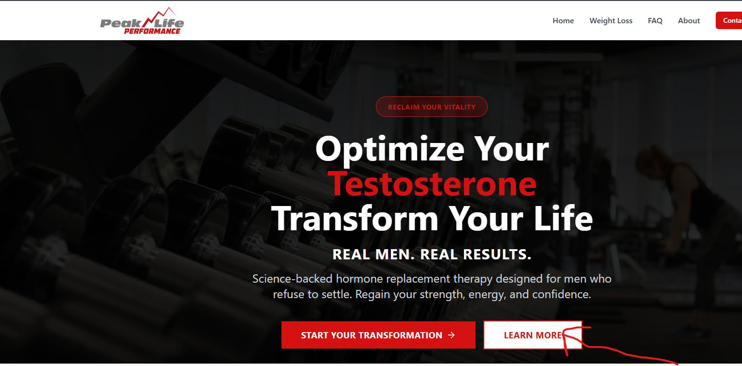
Arrow: Button does not work. Have it point to FAQs
Change red testosterone to Performance
Science-backed hormone optimization and peptide therapy designed for men who refuse to settle. Regain your strength, energy, and confidence.

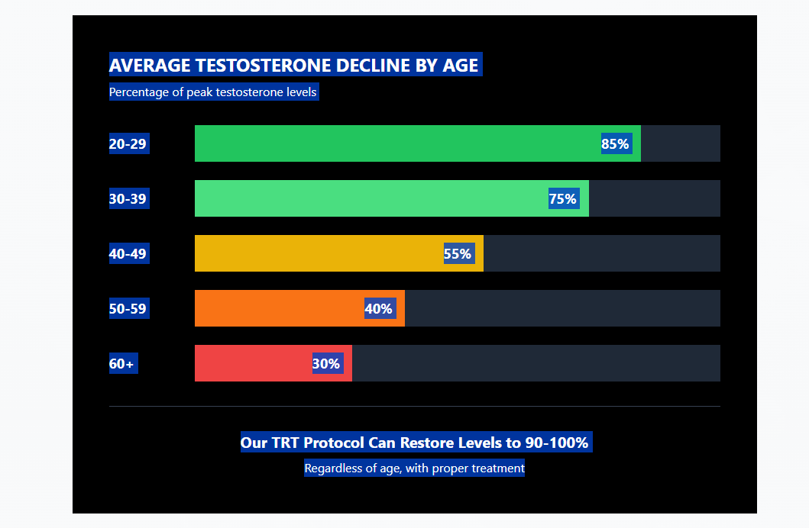

REPLACE WITH BELOW GRAPH:
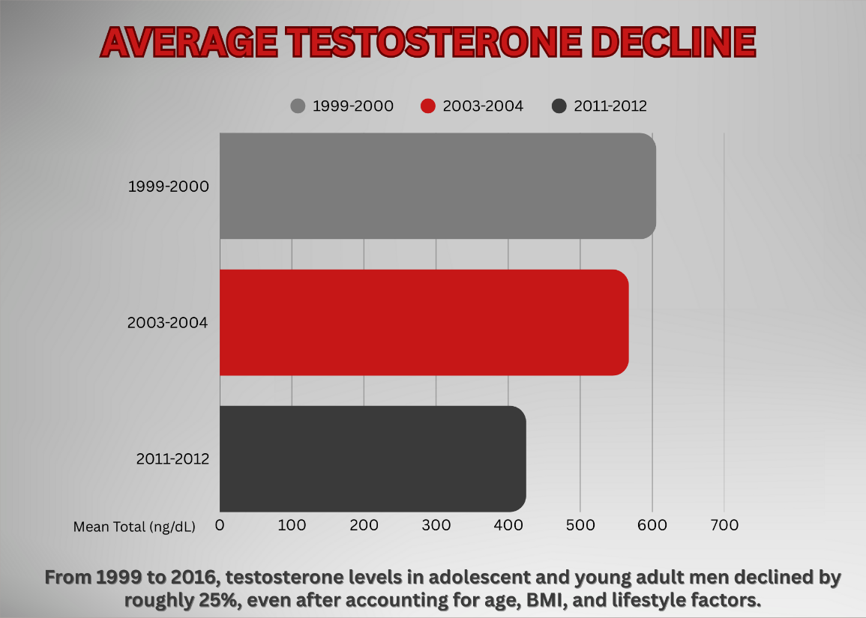

BELOW - Keep each window but remove statistics
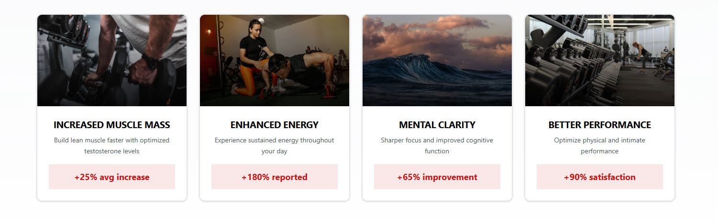
BELOW - Remove this box completely

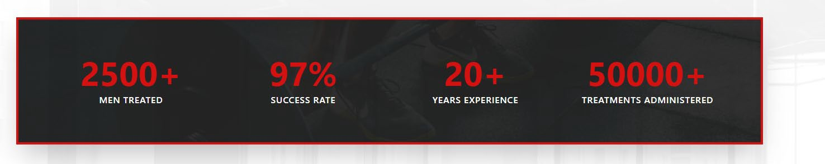

BELOW – Text in this box to be updated with the text below
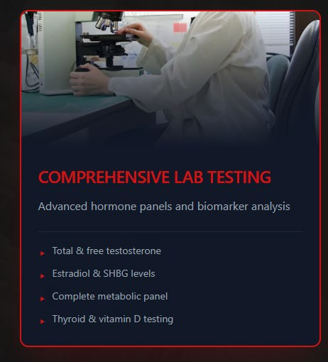

Headline:
Most Clinics Test Testosterone. We Test the System.
Body:
Checking testosterone alone is outdated.
At Peak Life Performance, our full TRT panel evaluates hormones, metabolism, cardiovascular risk, and long-term safety markers—so treatment is precise, personalized, and sustainable.
Our testing includes:
- Free & Total Testosterone
- Estradiol (E2)
- LH, FSH, DHEA-S, Prolactin
- PSA & prostate screening
- Thyroid function
- CBC, CMP, A1C
- Full lipid profile with cholesterol ratios
Footer line:
This is hormone optimization done the right way.

Ready to Reclaim Your Power?
Join the wave of men across the country who've transformed their lives through optimized testosterone levels and performance recovery. Your journey to Peak Life Performance starts now.

Get Free Consultation
BOTTOM OF PAGE:

Quick Links : Need to direct to topic, currently TRT
services, Success stories and contact direct to top of
page

Hours – Monday, Tuesday, Thursday, Friday 8 a.m. to
6 p.m. Closed Wednesday

FAQ PAGE

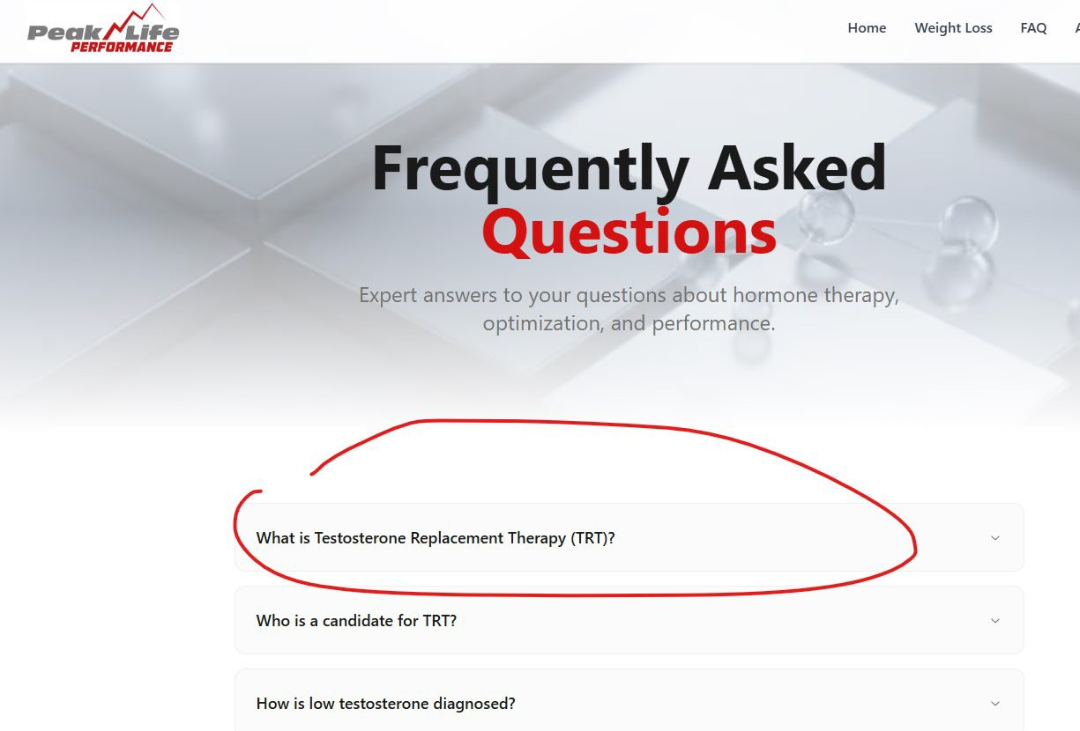
Change description: TRT is a medically supervised treatment that restores healthy testosterone levels in men with low testosterone, also called hypogonadism. Testosterone is important for energy, muscle mass, libido, mood, and overall well-being. TRT helps relieve symptoms such as fatigue, low sex drive, decreased strength, and brain fog, while safely monitoring hormone levels to optimize health.
Change description: Low testosterone is diagnosed with blood tests that measure total and free testosterone levels, often combined with a review of symptoms and medical history to ensure accurate assessment.
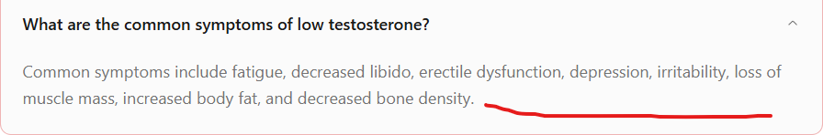

Add last sentence : Low testosterone can cause fatigue, decreased libido, erectile dysfunction, depression, irritability, loss of muscle mass, increased body fat, and decreased bone density. Recognizing these signs early can help guide treatment and improve overall health.
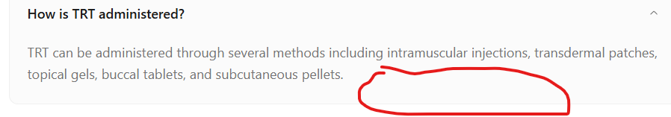

Add sentence: Your provider will help choose the method best suited to your needs and lifestyle.
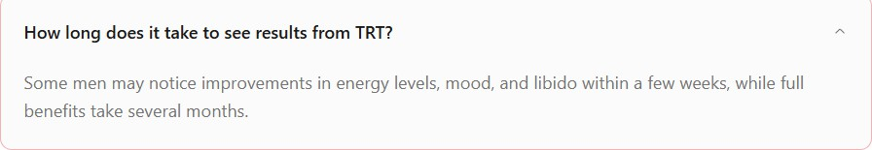
Add sentence: Some men notice improvements in energy, mood, and libido within a few weeks. Other beneﬁts, like increased strength and muscle mass, may take several months. Results vary by individual and depend on health, hormone levels, and adherence to the treatment plan.
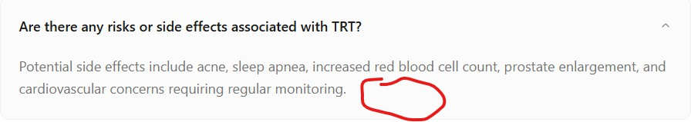
Add Sentence: TRT is generally safe when medically supervised, but potential side effects can include acne, sleep apnea, increased red blood cell count, prostate enlargement, and cardiovascular risks. Regular monitoring by your healthcare provider helps manage these risks and ensures safe, effective treatment.
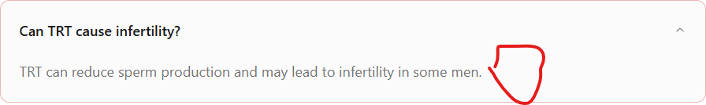
Add Sentence: TRT can reduce sperm production and may lead to infertility in some men. Using HCG alongside TRT can help maintain testicular function and support fertility while on therapy. It’s important to discuss fertility goals with your provider before starting treatment.
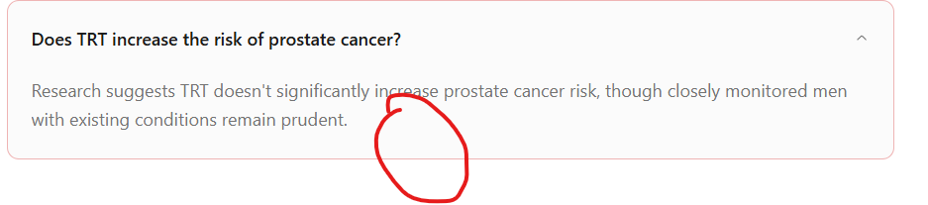

Expand: Research shows TRT does not signiﬁcantly raise prostate cancer risk. Men with existing prostate conditions should be monitored, but with regular check-ups and lab tests, TRT is generally safe and well-managed.


Expand: Follow-up visits with your doctor usually occur every 3 to 6 months to monitor testosterone levels and overall health. At our clinic, nurses closely track your labs and symptoms more frequently, ensuring your treatment is safe, effective, and tailored to your needs.
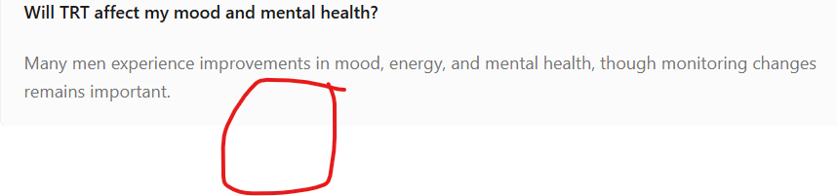
Expand: Many men notice improvements in mood, energy, focus, and overall mental well-being while on TRT. These beneﬁts can help reduce symptoms such as irritability, fatigue, and brain fog. Regular monitoring by your healthcare team ensures any changes in mood or mental health are addressed promptly for safe, effective treatment.
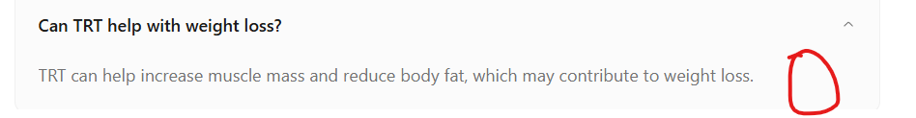
Expand: TRT can help increase muscle mass and improve metabolism, which may contribute to reducing body fat and supporting weight management. When combined with a healthy diet, exercise, and lifestyle changes, TRT can be an effective part of a comprehensive approach to achieving and maintaining a healthier body composition.

ABOUT PAGE
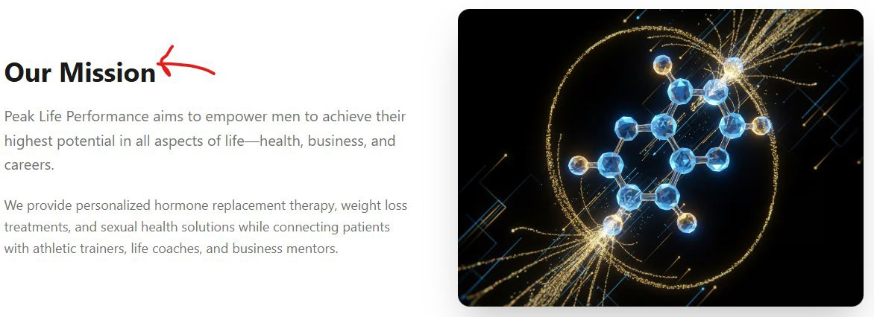
Peak Life Performance Mission Statement: At Peak Life Performance, our mission is to empower men to achieve their highest potential in all aspects of life- health, business, and careers. We are dedicated to optimizing male performance through personalize hormone optimization and peptide therapy, comprehensive weight loss treatments, and tailored sexual health solutions. By connecting our patients with a network of expert athletic trainers, life and performance coaches, and business and entrepreneurship mentors, we provide the tools and support necessary for holistic well-being and success. At our core, we believe in fostering a strong community where every man can thrive and reach peak performance in every area of life.
WEIGHT LOSS PAGE

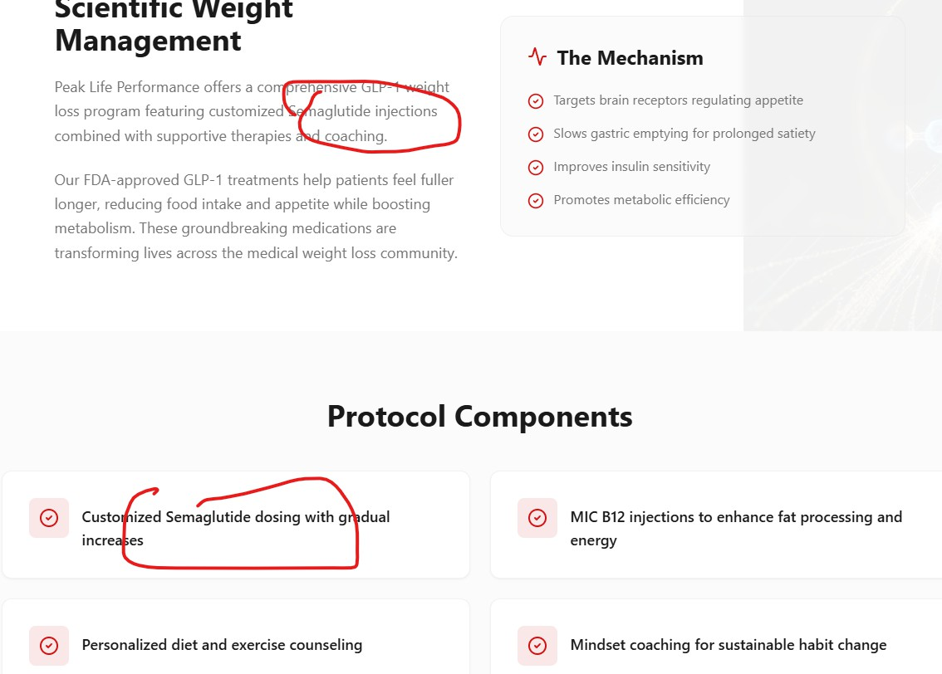
Change Semaglutide to GLP-1

We use a tirzepatide(GLP-1)/Glycine/B12 formula for our weight loss patients. So the info should include something along these lines:

Core Mechanism: Tirzepatide (Dual-Incretin Therapy)
Tirzepatide works through two hormone pathways at the same time:
1️⃣ GLP-1 Receptor Agonism (Gut → Brain → Pancreas)
GLP-1 (glucagon-like peptide-1) is a hormone released after eating.
Effects:
- Slows gastric emptying → you feel full longer
- Reduces appetite signaling in the brain (hypothalamus)
- Increases glucose-dependent insulin release
- Decreases glucagon (less glucose released from the liver)
Clinical result:
Lower calorie intake, improved blood sugar control, reduced cravings.

2️⃣ GIP Receptor Agonism (Metabolic Amplifier)
GIP (glucose-dependent insulinotropic polypeptide) is another incretin hormone.
Effects:
- Enhances insulin sensitivity
- Improves fat metabolism and nutrient partitioning
- May reduce adipose inflammation
- Works synergistically with GLP-1 to enhance weight loss and metabolic health
Why this matters:
Tirzepatide’s dual GLP-1 + GIP activity leads to greater fat loss and metabolic improvements than GLP-1 alone.

Why Add Glycine?
Glycine is not just a filler—it has supportive metabolic and neurologic roles.
Glycine mechanisms:
- Supports glucose metabolism and insulin sensitivity
- Acts as an inhibitory neurotransmitter, helping calm the nervous system
- May reduce nausea and GI irritation
- Supports mitochondrial function and detox pathways
- Plays a role in collagen synthesis and tissue repair
Clinical benefit when paired with tirzepatide:
- Improved tolerability (less nausea for some patients)
- Better metabolic efficiency
- Potential support for sleep quality and recovery

Why Add Vitamin B12?
B12 (cobalamin) is essential for energy production and nerve function.
B12 mechanisms:
- Required for red blood cell production
- Supports mitochondrial energy generation
- Essential for neurologic health
- Helps prevent fatigue during caloric restriction
- Supports methylation and metabolic pathways
Why it matters with GLP-1 therapy:
- Weight loss and reduced food intake can lower B12 intake over time
- Helps offset fatigue commonly reported early in GLP-1 therapy
- Supports adherence and perceived energy levels

Add Additional services tab:
Move HCG section at bottom of weight loss to this tab
At Peak Life Performance, optimization means more than hormones alone. Our Additional Services support recovery, energy, fertility, sexual function, and sleep—key drivers of health, confidence, and long-term success. Every service is designed to help men perform at their peak in life, business, and relationships.

Additional services need to include:
Additional Services
A complete approach to performance, recovery, and long-term health.

Sermorelin (Peptide Therapy | Performance & Recovery)
Peptide-based growth hormone optimization designed to support deep sleep, recovery, lean muscle maintenance, fat metabolism, and overall vitality—without suppressing natural hormone production.

Vitamin B12 Injections
Targeted support for energy, metabolism, neurologic function, and red blood cell production. Commonly used to combat fatigue, support weight loss programs, and enhance overall performance.

hCG for Fertility Preservation
Human chorionic gonadotropin (hCG) is used to support testicular function and sperm production, often alongside or independent of testosterone therapy, for men concerned about fertility preservation or family planning.

Sexual Function Medications
Personalized treatment options for erectile function, libido, and sexual performance, tailored to each patient’s physiology—available with or without testosterone therapy.

Therapeutic Massage (Thursdays)
In-clinic massage therapy available weekly to support muscle recovery, stress reduction, circulation, and nervous system balance as part of a comprehensive performance and wellness plan.

Sleep Study & Analysis
Advanced sleep evaluation to identify issues such as sleep apnea, poor sleep quality, or disrupted sleep architecture—because optimized hormones, metabolism, and recovery all start with quality sleep.

POTENTIAL ADDITIONAL FAQ FOR SERMORELIN

Frequently Asked Questions (FAQ)

Who Is Sermorelin Therapy For?
Sermorelin may be beneficial for adults experiencing symptoms associated with declining growth hormone levels, such as low energy, poor sleep quality, difficulty building muscle, increased body fat, or slower recovery. It is commonly used by individuals focused on performance optimization, healthy aging, and overall wellness.

How Is Sermorelin Administered?
Sermorelin is typically administered as a small subcutaneous injection, often taken in the evening to align with the body’s natural growth hormone release during sleep. Our providers will guide you through proper use and dosing.

How Long Does It Take to See Results?
Some individuals notice improvements in sleep quality and energy within 2–4 weeks. More visible changes in body composition, recovery, and overall vitality may develop over 8–12 weeks with consistent therapy. Results vary based on lifestyle, age, and individual physiology.

Is Sermorelin Safe?
Sermorelin has a favorable safety profile when prescribed and monitored by a qualified healthcare provider. Because it stimulates your body’s own hormone production rather than replacing hormones directly, it is generally considered lower risk than synthetic growth hormone therapies. Mild side effects may include temporary redness at the injection site or mild headaches.

How Is Sermorelin Different From HGH?
Unlike synthetic HGH, sermorelin encourages natural, pulsatile growth hormone release from the pituitary gland. This helps preserve normal hormonal feedback mechanisms and reduces the risk of hormone suppression.

Will Sermorelin Help With Weight Loss?
Sermorelin supports fat metabolism and lean muscle preservation, which may contribute to improved body composition. It works best when combined with proper nutrition, resistance training, and healthy sleep habits.

Do I Need Lab Testing Before Starting?
Yes. Proper lab testing helps determine whether sermorelin is appropriate for you and allows us to personalize your treatment plan. Ongoing monitoring ensures safety and optimal results.

Is Sermorelin FDA Approved?
Sermorelin was previously FDA-approved for diagnostic use in children and is currently prescribed through compounding pharmacies for off-label adult wellness and performance optimization under medical supervision.

Why Choose Peak Life Performance?
At Peak Life Performance, we take a personalized, evidence-based approach to peptide therapy. Your program is guided by:
- Comprehensive lab analysis

- Individualized dosing protocols

- Ongoing provider oversight

- Performance, recovery, and longevity optimization

We don’t believe in one-size-fits-all treatment—your biology, goals, and lifestyle matter.

Optional Disclaimer (Website Footer Style)
Peptide therapy is not intended to diagnose, treat, cure, or prevent any disease. Individual results may vary. All therapies are provided under medical supervisio

Peptide Therapy — Sermorelin

What Is Sermorelin?
Sermorelin is a growth hormone releasing hormone (GHRH) peptide that gently stimulates your pituitary gland to produce more of your body’s own natural growth hormone (GH). Rather than supplying synthetic hormones, sermorelin works with your physiology, encouraging pulsatile, healthy GH release that supports metabolism, recovery, vitality, and healthy aging.

How It Works
Sermorelin mimics the first 29 amino acids of your body’s own GH-releasing hormone. It binds to receptors in the pituitary gland to trigger increased secretion of growth hormone in rhythmic bursts—especially during deep sleep—and preserves your body’s natural feedback systems without suppressing pituitary function.

Sermorelin Peptide Therapy
Sermorelin is a synthetic analogue of growth hormone–releasing hormone (GHRH) that stimulates the pituitary gland to produce and release the body’s own natural growth hormone in a physiologic, pulsatile pattern (Thorner et al., 1997; Yuen & Dunger, 2007). Unlike synthetic human growth hormone (HGH), sermorelin works by encouraging endogenous hormone production rather than replacing hormones directly (Vance, 2003).

How Sermorelin Works
Sermorelin mimics the first 29 amino acids of endogenous GHRH and binds to receptors in the pituitary gland, signaling the release of growth hormone (Thorner et al., 1997). This process preserves the body’s natural hormonal feedback mechanisms and supports downstream production of insulin-like growth factor-1 (IGF-1), a primary mediator of growth hormone activity (Yuen & Dunger, 2007).

Potential Benefits of Sermorelin Therapy

Supports Natural Growth Hormone Production
Sermorelin has been shown to increase endogenous growth hormone secretion and IGF-1 levels, supporting metabolic health and cellular repair

Improved Sleep Quality
Growth hormone is released primarily during deep (slow-wave) sleep, and optimizing GH secretion may support more restorative sleep patterns

Enhanced Energy and Vitality
Growth hormone plays a role in energy metabolism and tissue regeneration, and increased physiologic GH output may contribute to improved daytime energy levels

Body Composition Support
Growth hormone promotes lipolysis (fat breakdown) and helps preserve lean muscle mass, which may support healthier body composition when combined with proper nutrition and exercise

Recovery and Tissue Repair
Growth hormone is involved in protein synthesis, tissue repair, and cellular regeneration, and stimulating natural GH release may aid recovery from physical training and exertion

Skin, Collagen, and Connective Tissue Health
Growth hormone influences collagen synthesis and connective tissue maintenance, which may contribute to improved skin elasticity

